

SUBMITTED BY: SUBMITTED TO
Name: Suhani Sethi Dr. Virender Kadyan
BATCH: B33
SAP ID: 590025966
SEMESTER-I
2025-2026

Experiment 1
- Write a C program to print “ Hello World”
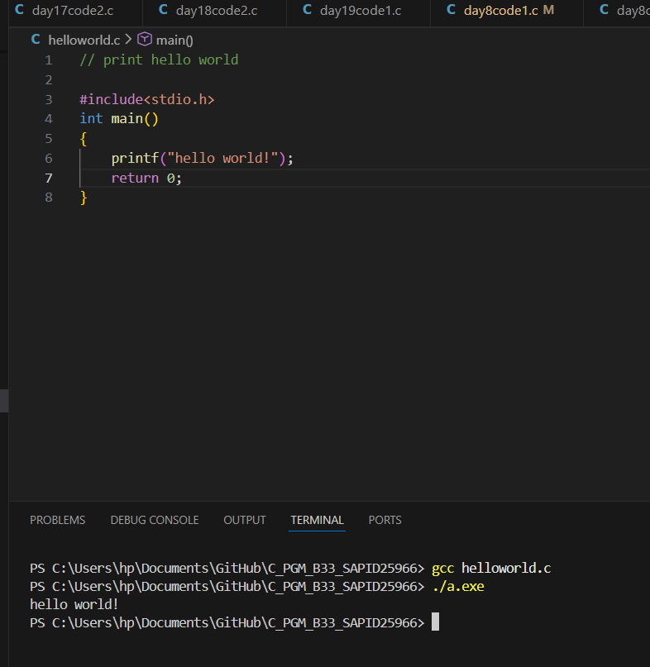
- Write a C Program to print the address in multiple lines (new line).
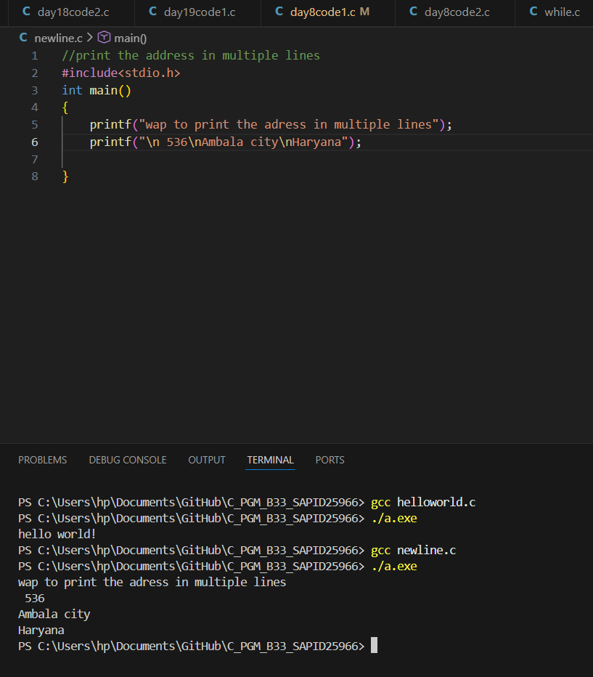
- Write a program that prompts the user to enter their name and age.
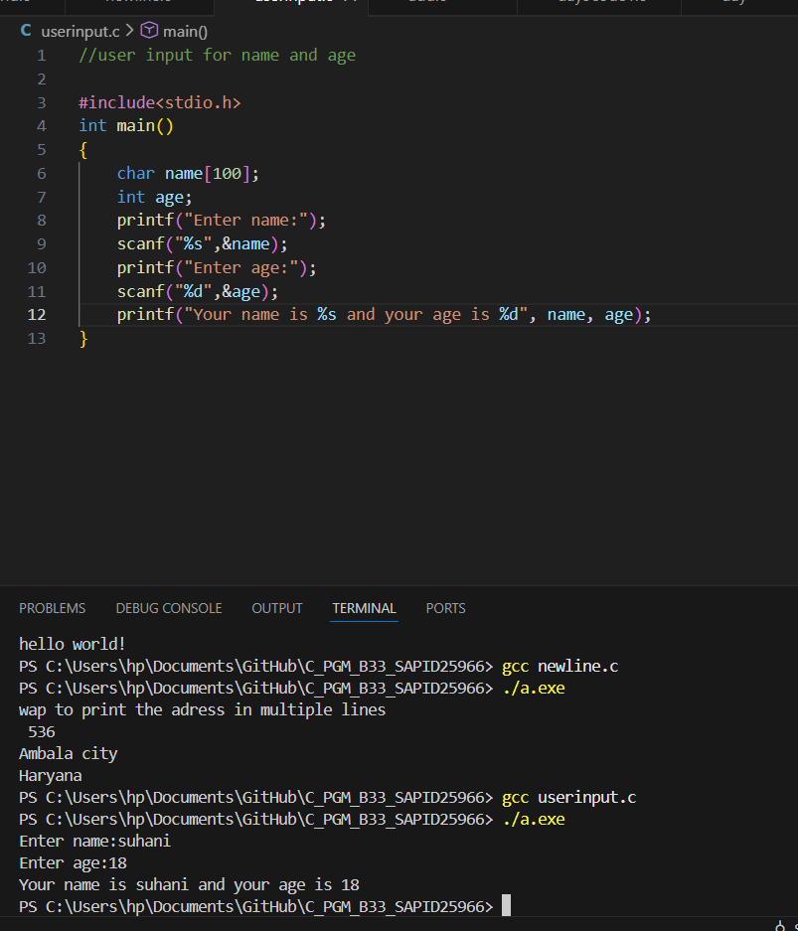
- Write a C program to add two numbers, take number from user.

Experiment 2: Operators
- WAP a C program to calculate the area and perimeter of a rectangle based on its length and width.
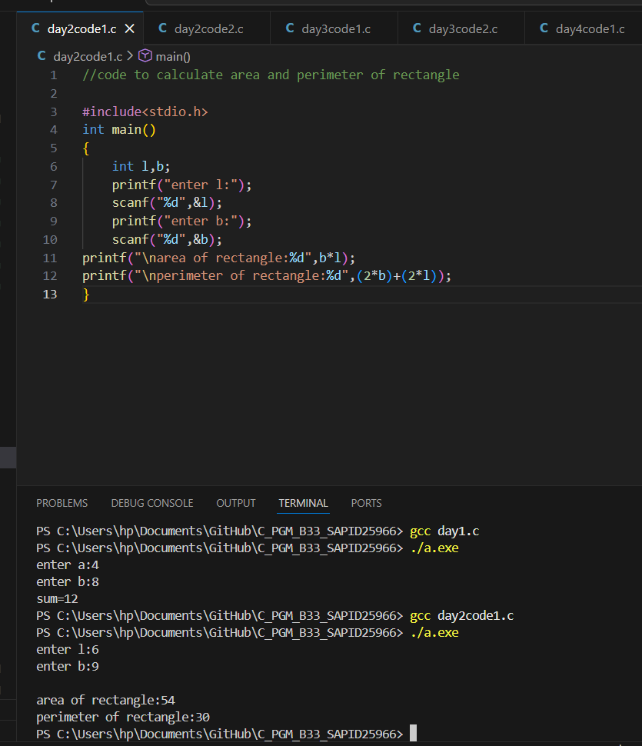
- WAP a C program to Convert temperature from Celsius to Fahrenheit using the formula: F = (C * 9/5) + 32.
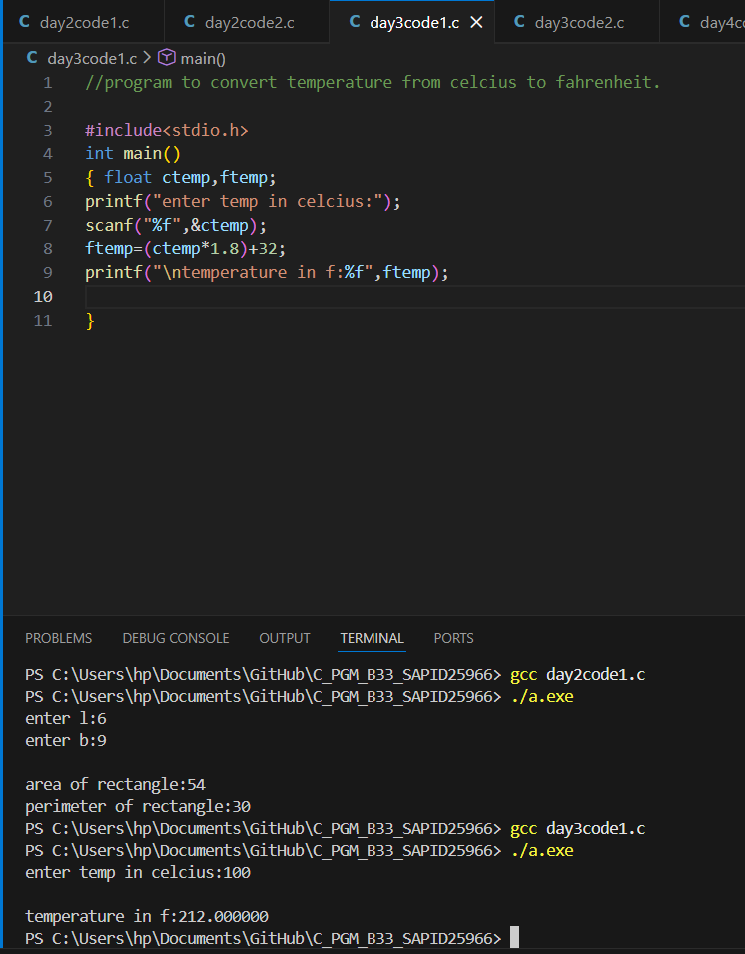
Experiment 3.1: Conditional Statements
- WAP to take check if the triangle is valid or not. If the validity is established, do check if the triangle is isosceles, equilateral, right angle, or scalene. Take sides of the triangle as input from a user.
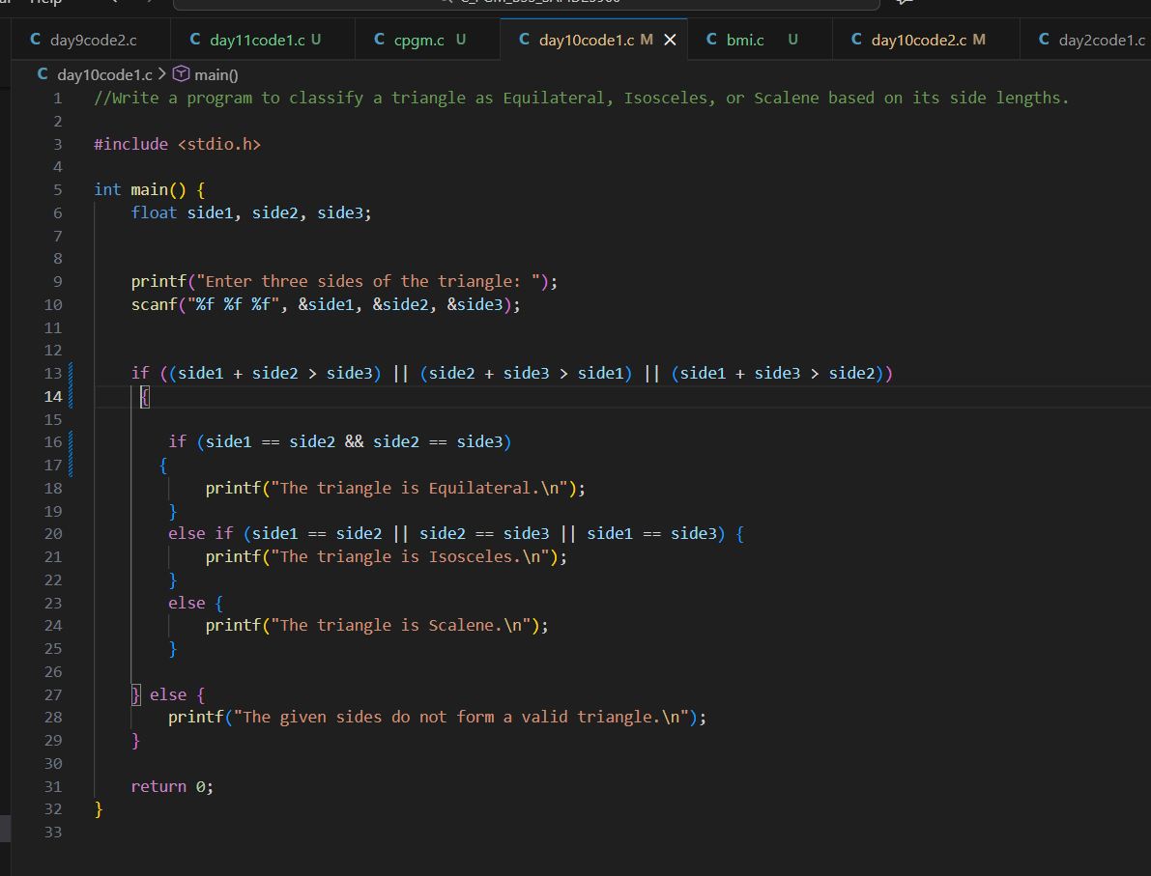
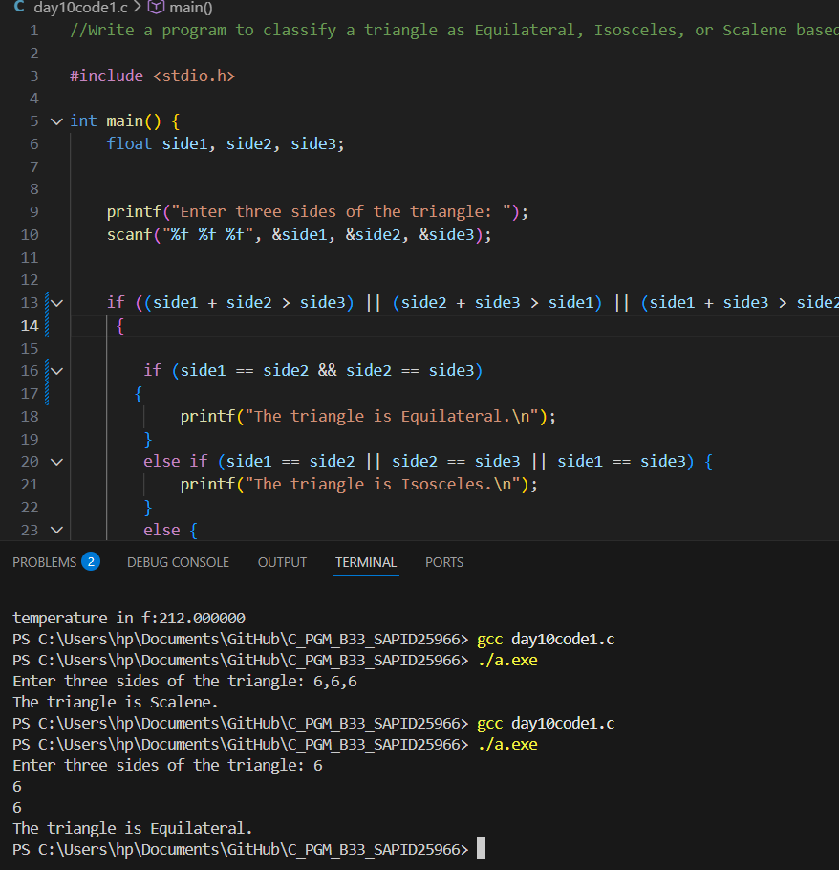
2. WAP to compute the BMI Index of the person and print the BMI values as per the following ranges. You can use the following formula to compute BMI= weight(kgs)/Height(Mts)*Height(Mts).
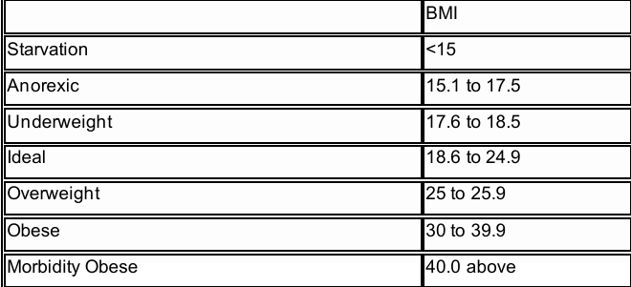
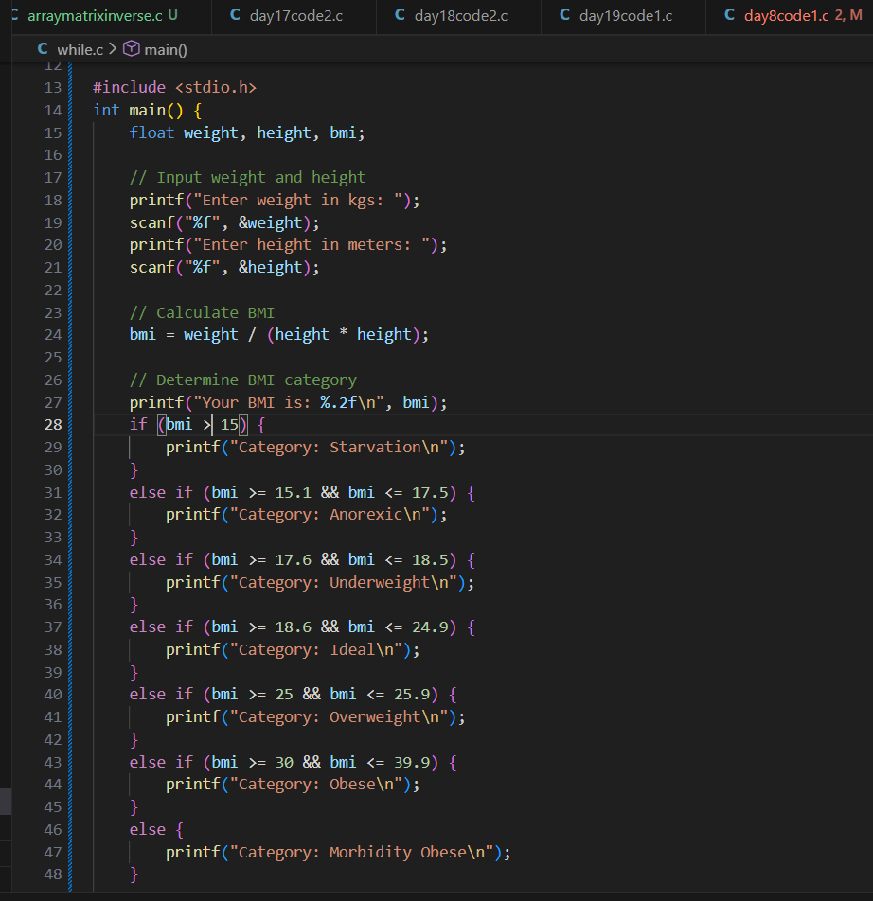
- WAP to check if three points (x1,y1), (x2,y2) and (x3,y3) are collinear or not.
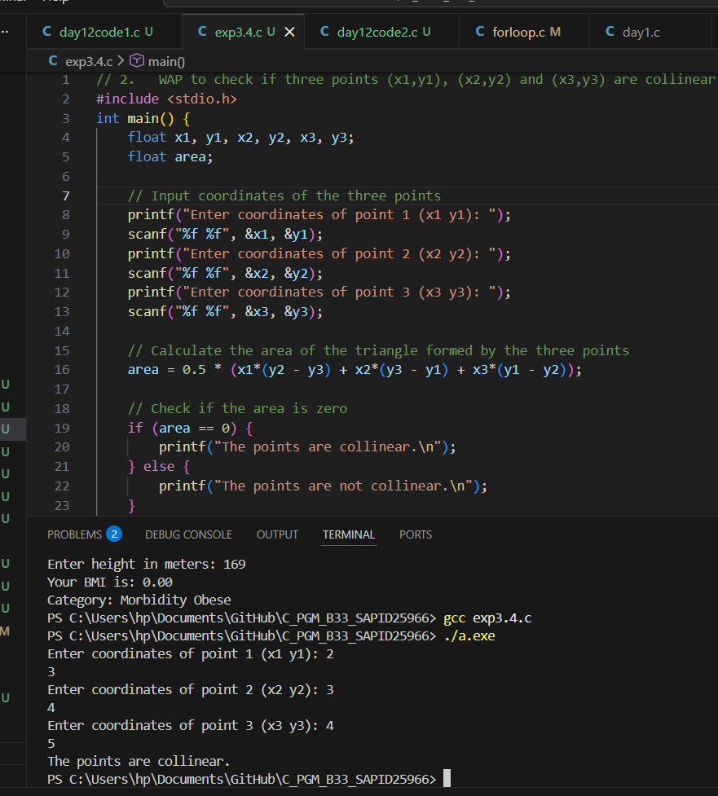

- According to the gregorian calendar, it was Monday on the date 01/01/01. If Any year is input through the keyboard write a program to find out what is the day on 1st January of this year. 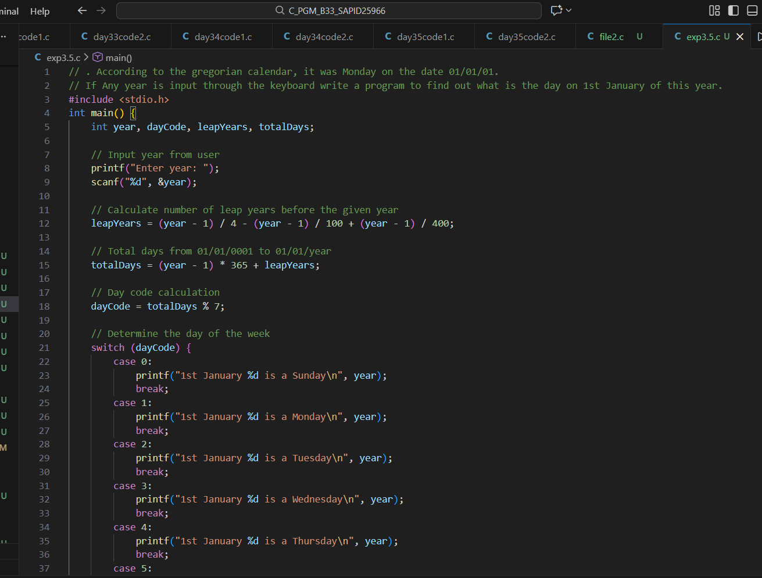
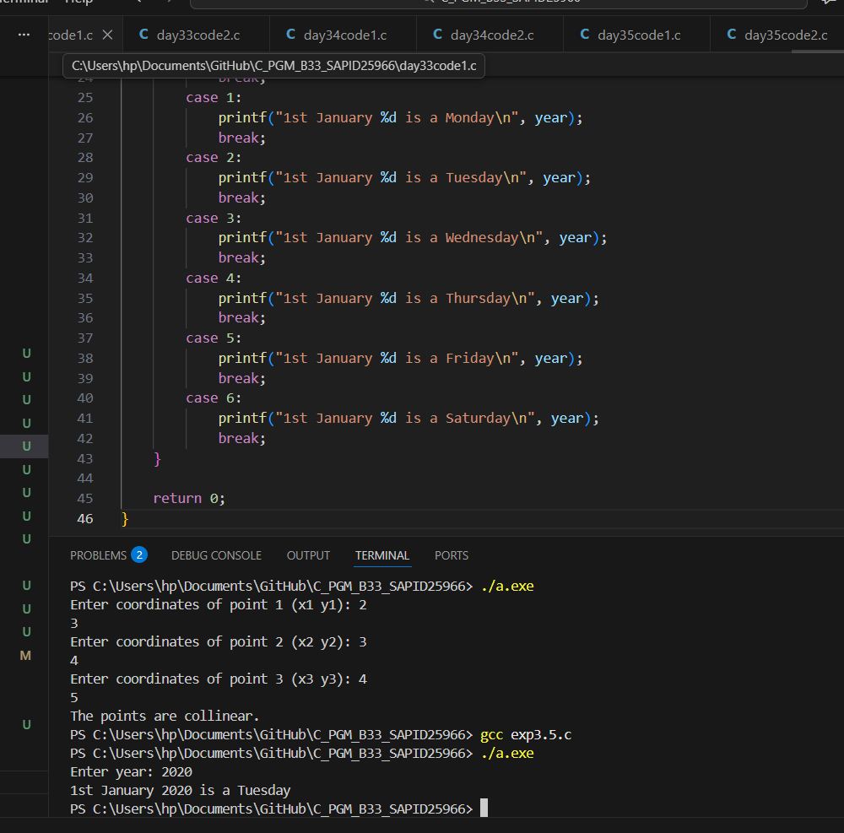
- WAP using ternary operator, the user should input the length and breadth of a rectangle, one has to find out which rectangle has the highest perimeter. The minimum number of rectangles should be three.
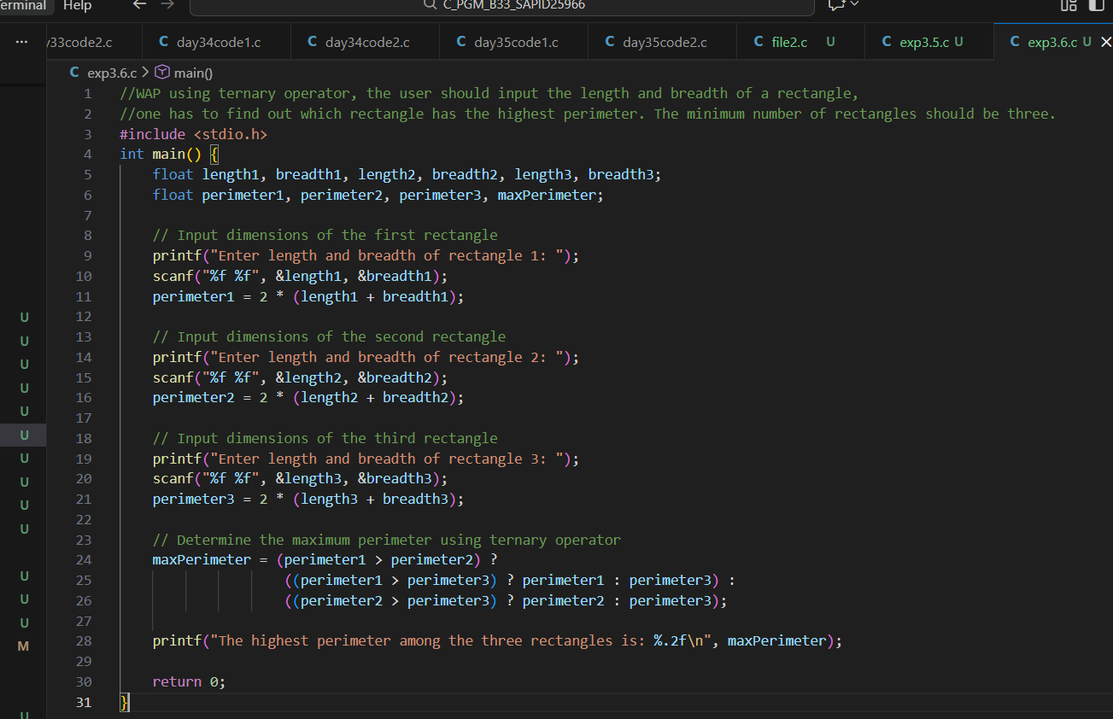

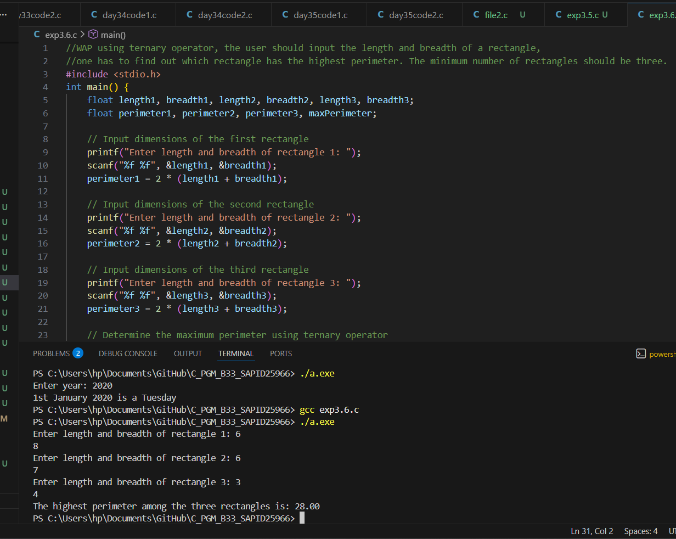

Experiment 3.2: Loops
- WAP to enter numbers till the user wants. At the end, it should display the count of positive, negative, and Zeroes entered.
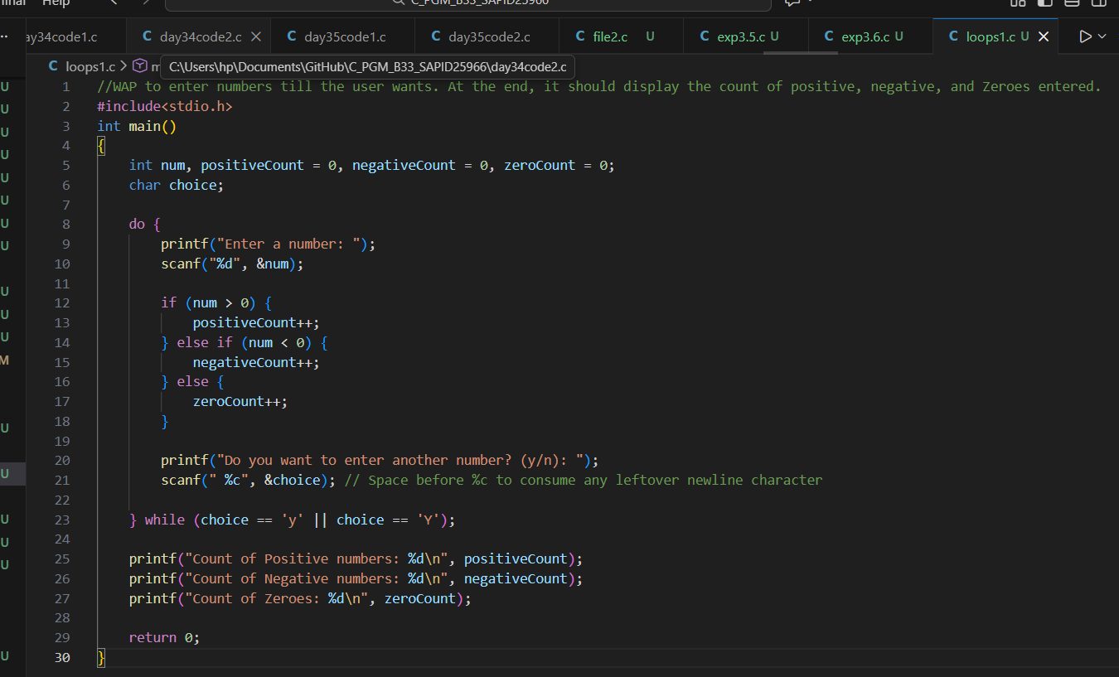
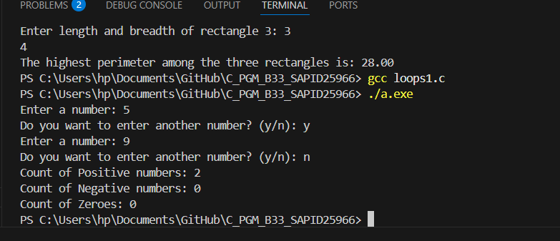

- WAP to print the multiplication table of the number entered by the user. It should be in the correct formatting. Num * 1 = Num
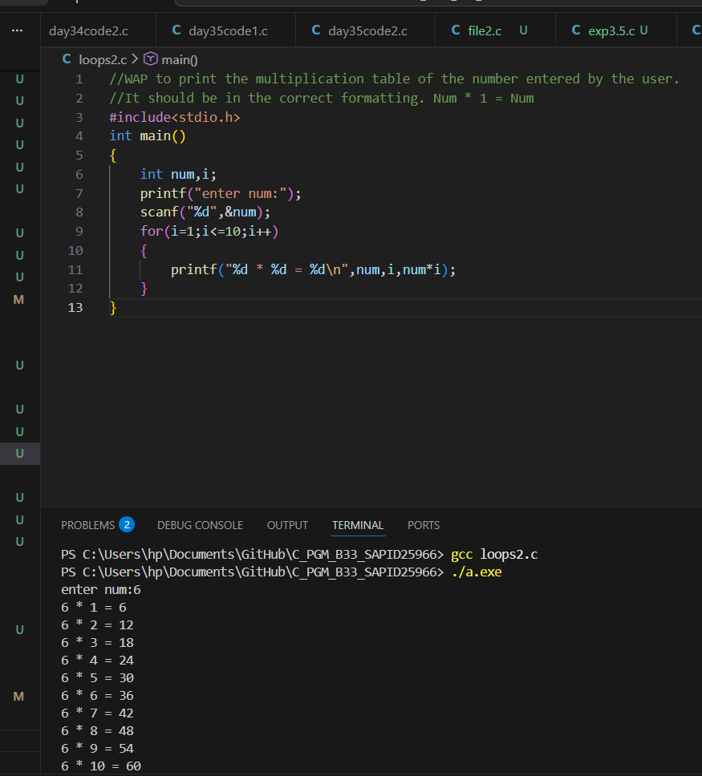

- WAP to generate the following set of output.
1
2 3
4 5 6
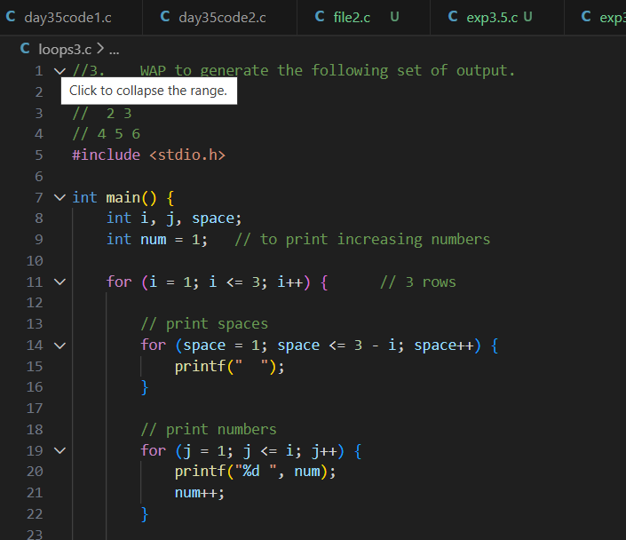
The output was 1
2 3
4 5 6

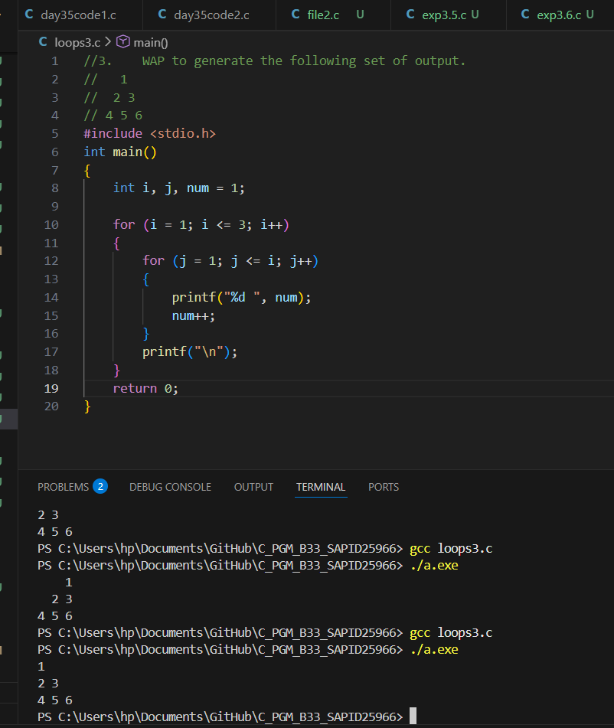
I was not able to achieve triangle pattern

- The population of a town is 100000. The population has increased steadily at the rate of 10% per year for the last 10 years. Write a program to determine the population at the end of each year in the last decade.
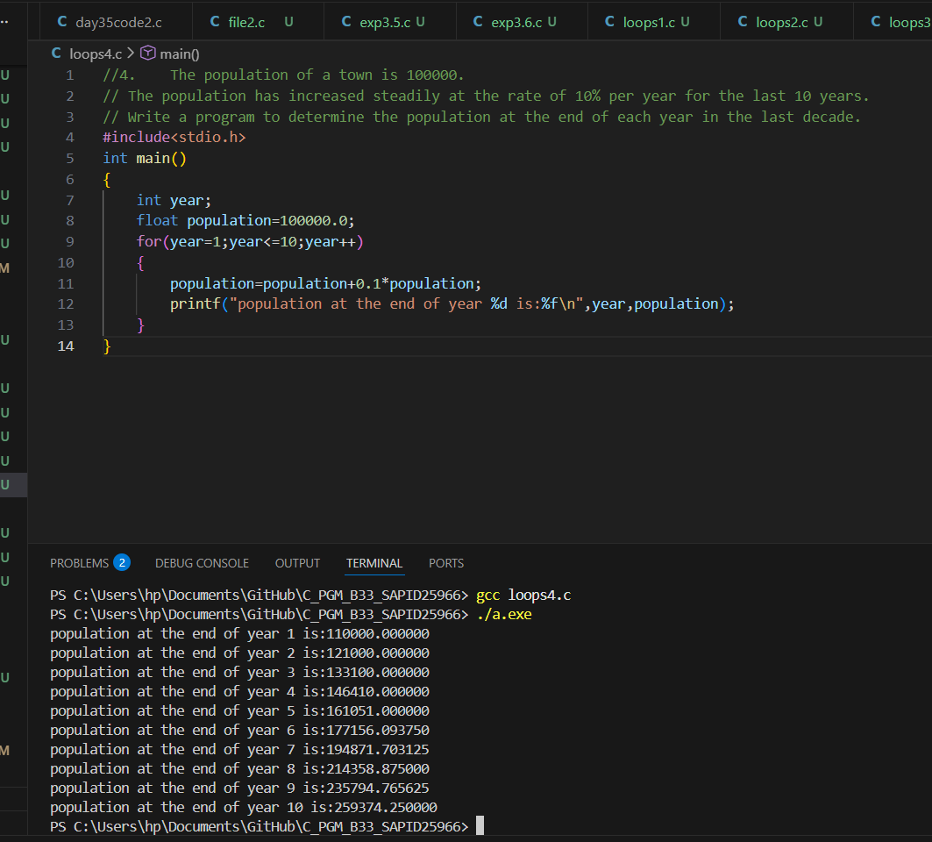

- Ramanujan Number is the smallest number that can be expressed as the sum of two cubes in two different ways. WAP to print all such numbers up to a reasonable limit. Example of Ramanujan number: 1729 12^3 + 1^3 and 10^3 + 9^3. for a number L=20(that is limit)

Did not understand

Experiment 4: Variable and Scope of Variable
- Declare a global variable outside all functions and use it inside various functions to understand its accessibility.
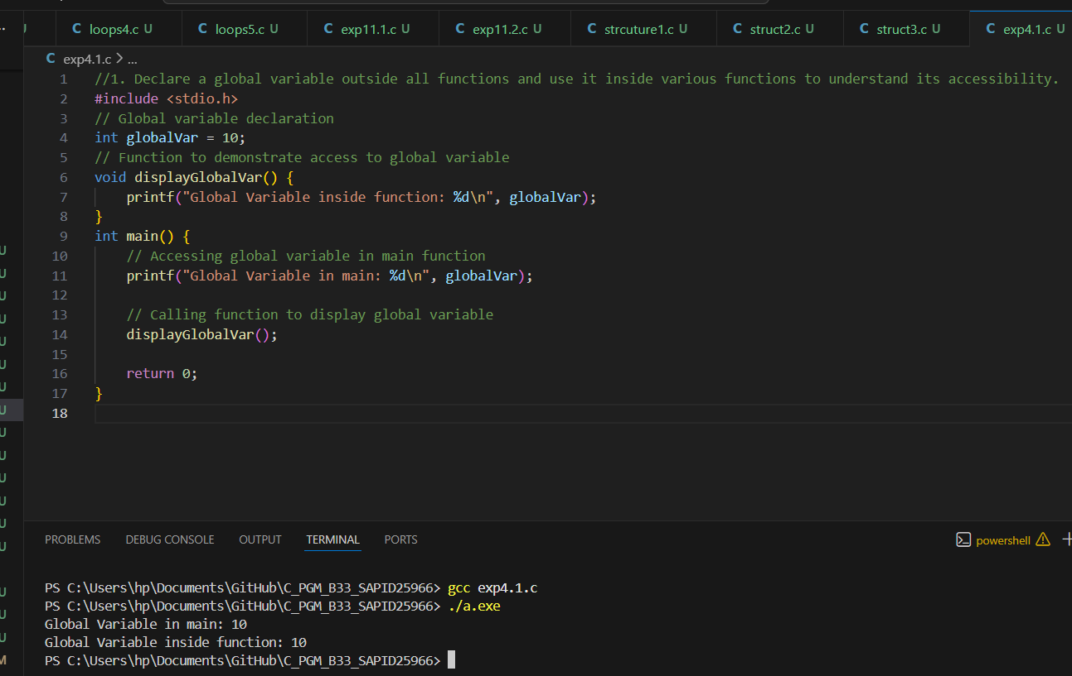
- Declare a local variable inside a function and try to access it outside the function. Compare this with accessing the global variable from within the function.
- 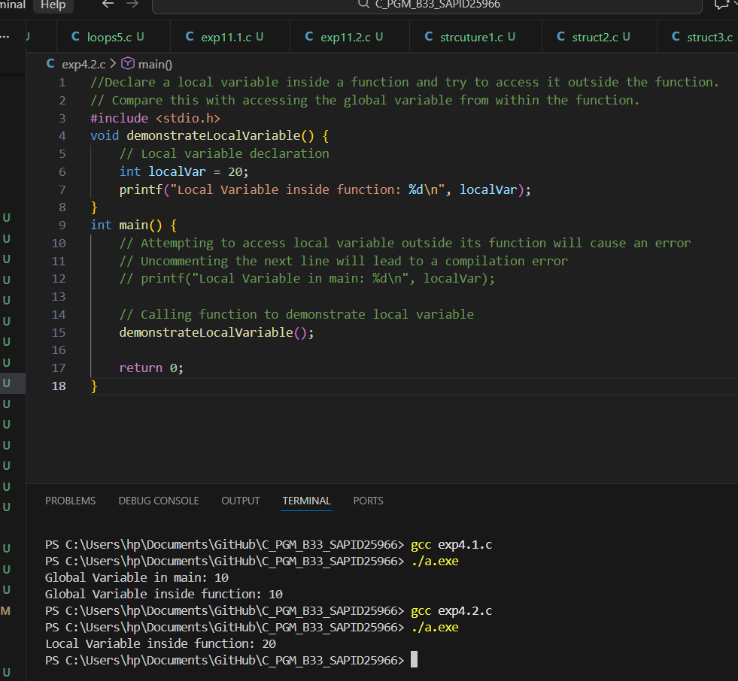

- Declare variables within different code blocks (enclosed by curly braces) and test their accessibility within and outside those blocks.

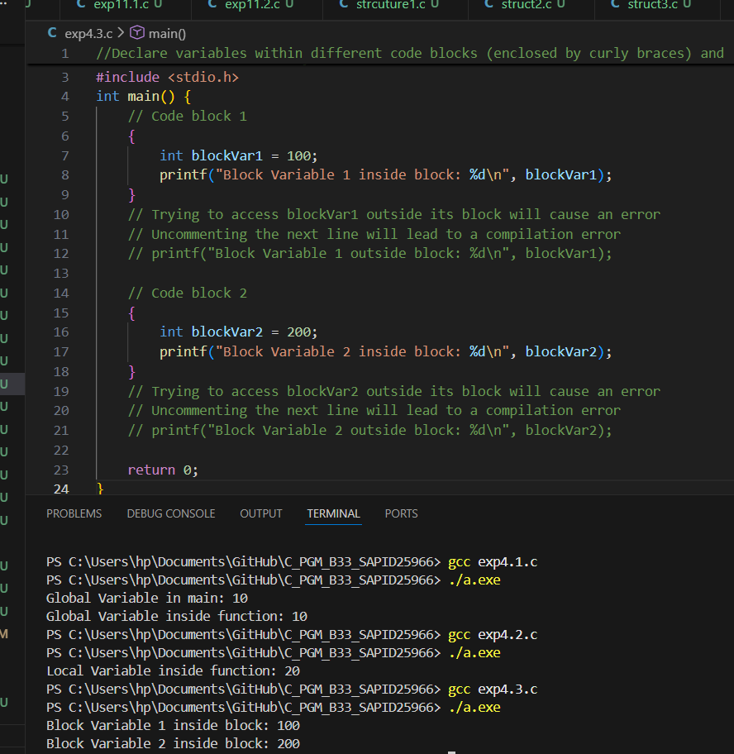
- Declare a static local variable inside a function. Observe how its value persists across function calls.
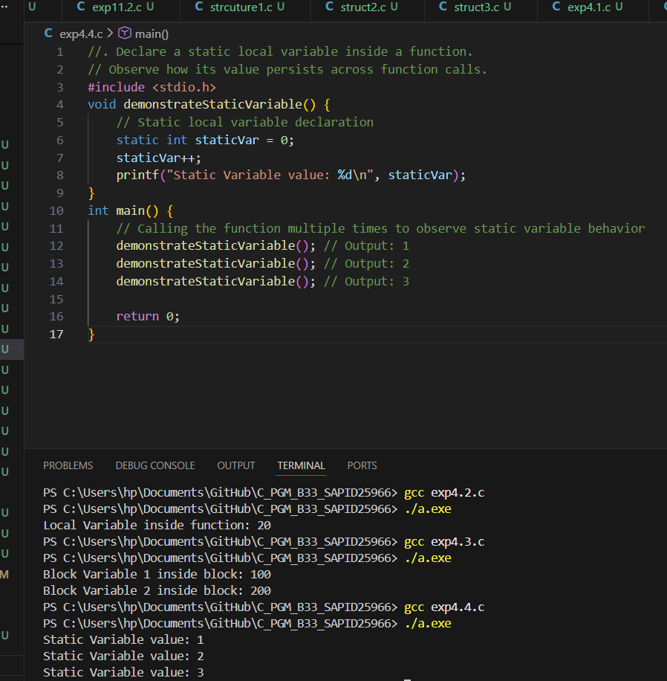
Experiment 5: Array
- WAP to read a list of integers and store it in a single dimensional array. Write a C program to print the second largest integer in a list of integers.
Did not understand at first , completed a week later
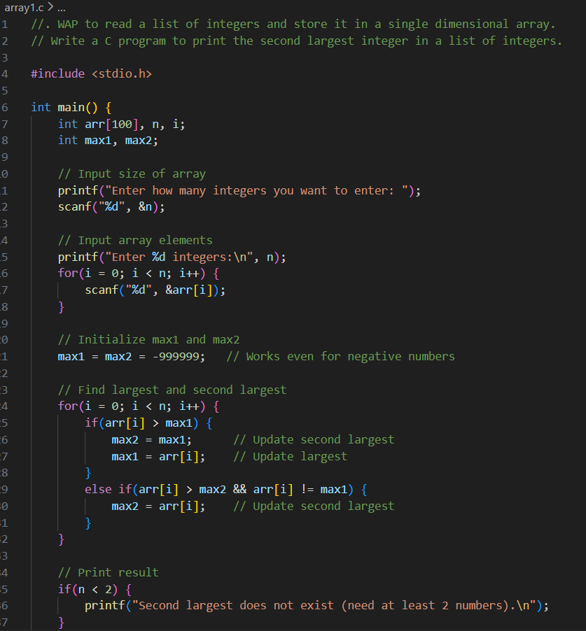
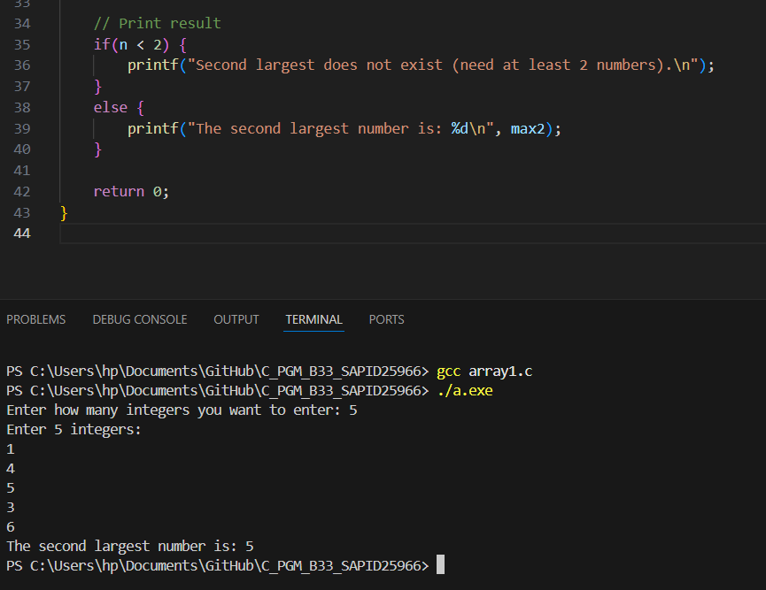

- WAP to read a list of integers and store it in a single dimensional array. Write a C program to count and display positive, negative, odd, and even numbers in an array.
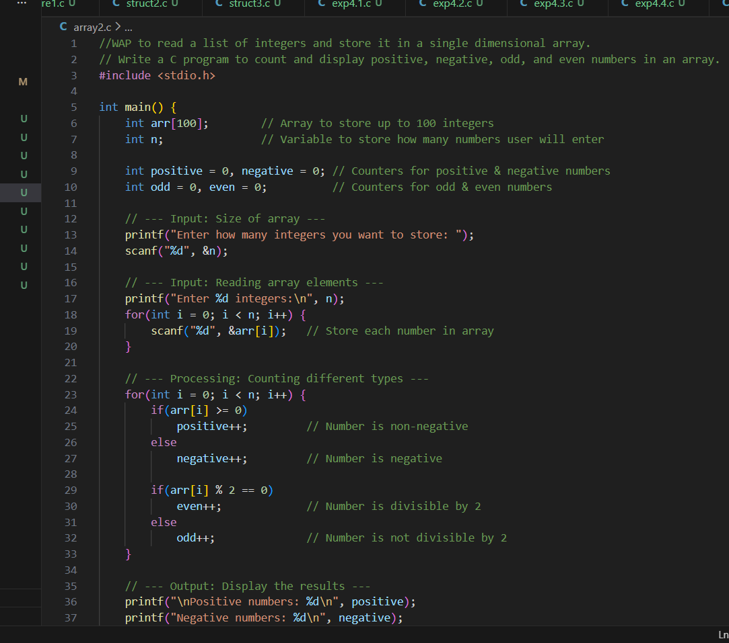
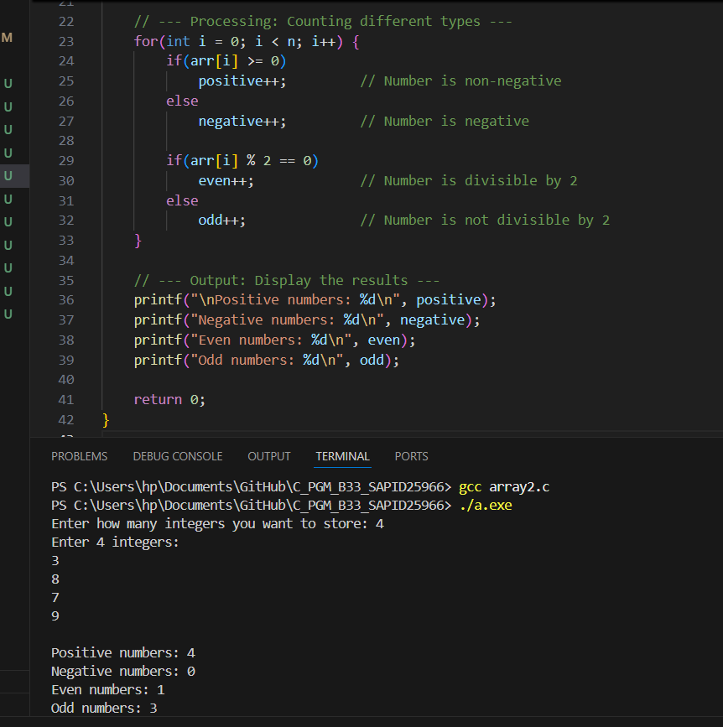
- WAP to read a list of integers and store it in a single dimensional array. Write a C program to find the frequency of a particular number in a list of integers.
- 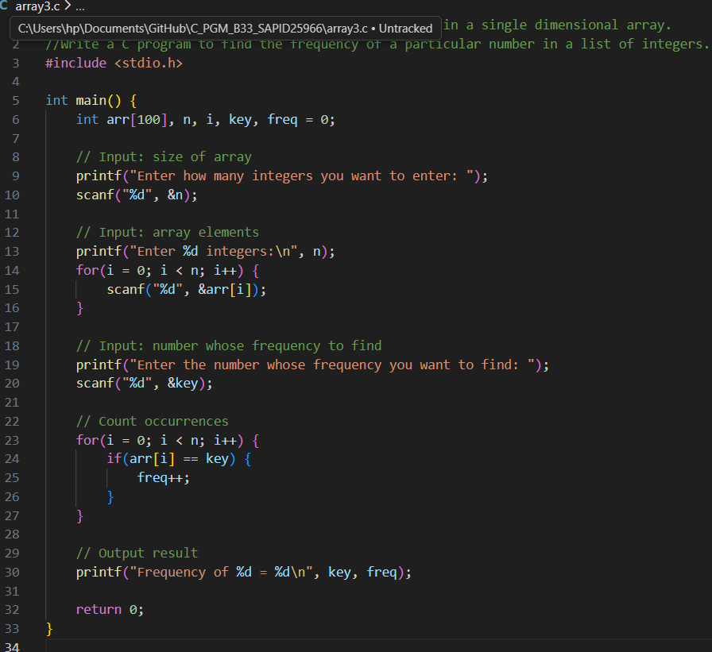
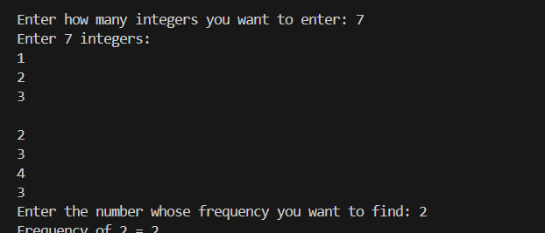

- WAP that reads two matrices A (m x n) and B (p x q) and computes the product A and B. Read matrix A and matrix B in row major order respectively. Print both the input matrices and resultant matrix with suitable headings and output should be in matrix format only. Program must check the compatibility of orders of the matrices for multiplication. Report appropriate message in case of incompatibility.
Unable to do

Experiment 6: Functions
1. Develop a recursive and non-recursive function FACT(num) to find the factorial of a number, n!, defined by FACT(n) = 1, if n = 0. Otherwise, FACT(n) = n * FACT(n-1). Using this function, write a C program to compute the binomial coefficient. Tabulate the results for different values of n and r with suitable messages.
2. Develop a recursive function GCD (num1, num2) that accepts two integer arguments. Write a C program that invokes this function to find the greatest common divisor of two given integers.
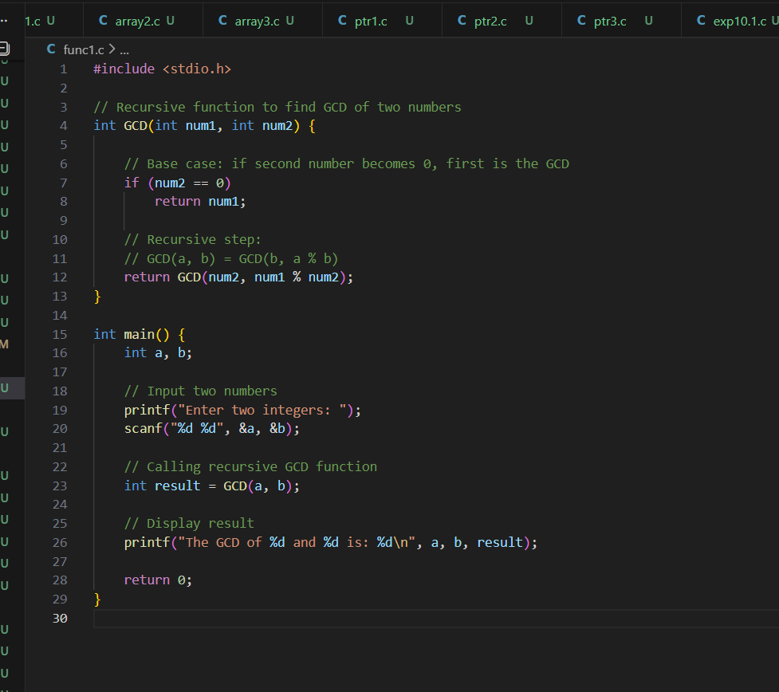
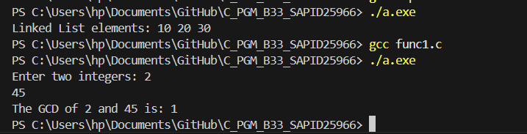

3. Develop a recursive function FIBO (num) that accepts an integer argument. Write a C program that invokes this function to generate the Fibonacci sequence up to num.

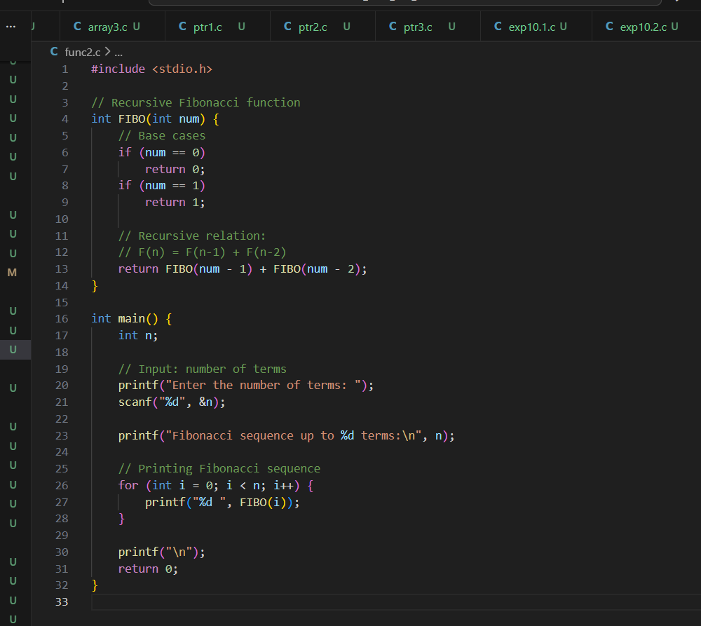
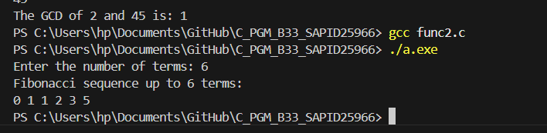

Experiment 7: Structures and Union
- Write a C program that uses functions to perform the following operations: a. Reading a complex number. b. Writing a complex number. c. Addition and subtraction of two complex numbers Note: represent complex number using a structure.
- 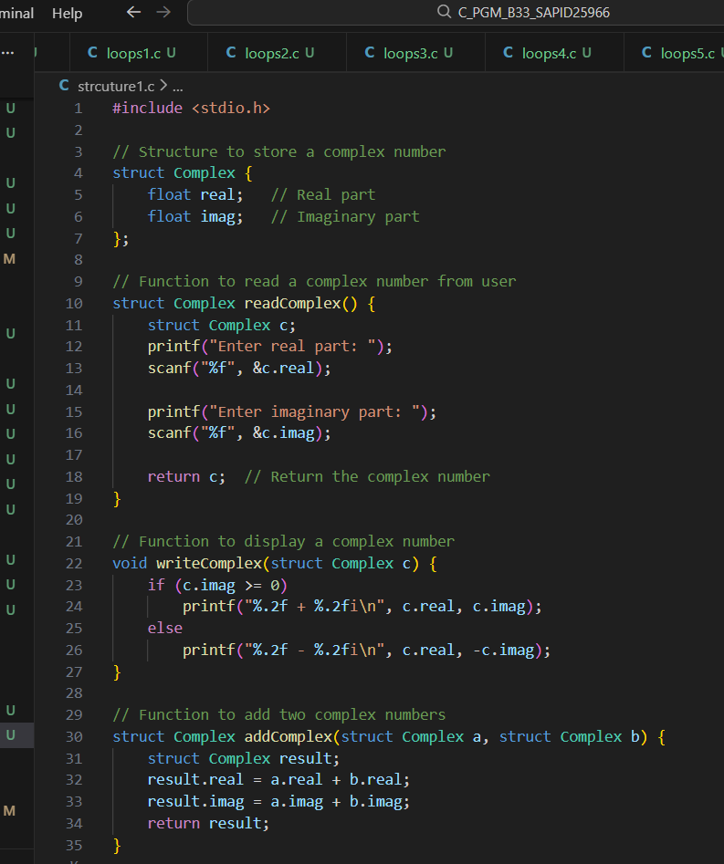
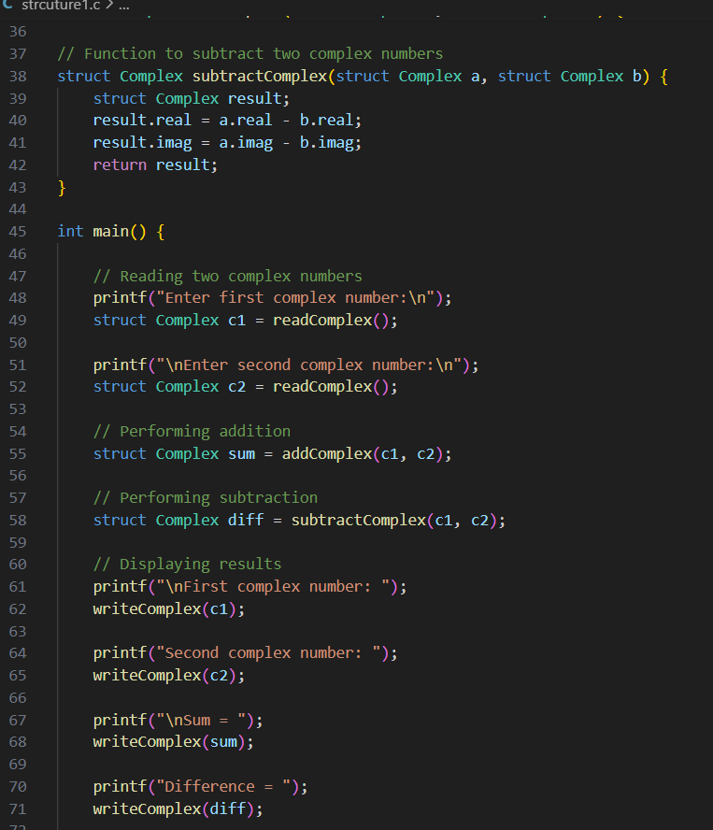
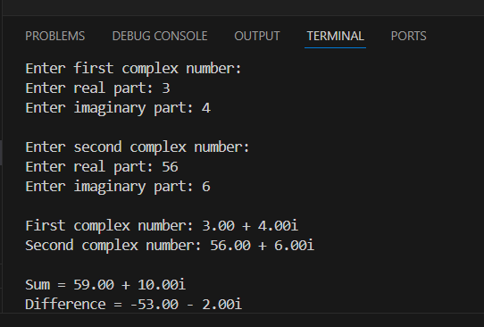

- Write a C program to compute the monthly pay of 100 employees using each employee‗s name, basic pay. The DA is computed as 52% of the basic pay. Gross-salary (basic pay + DA). Print the employees name and gross salary.
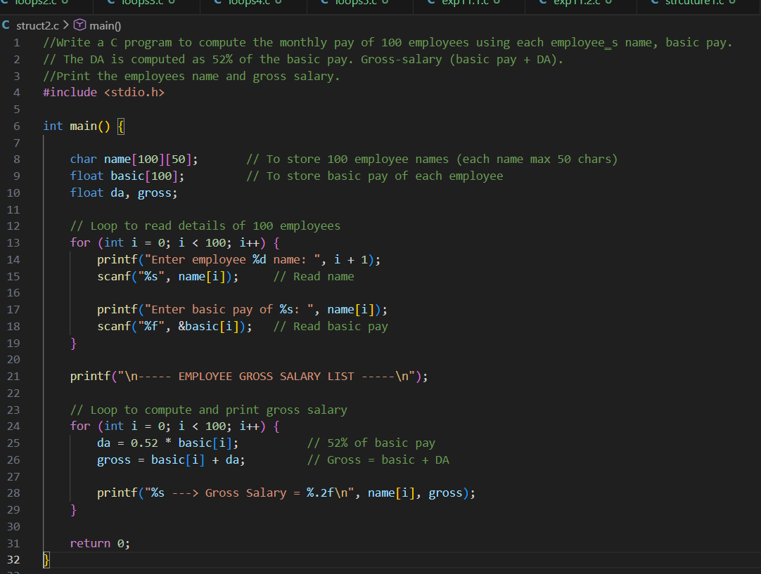
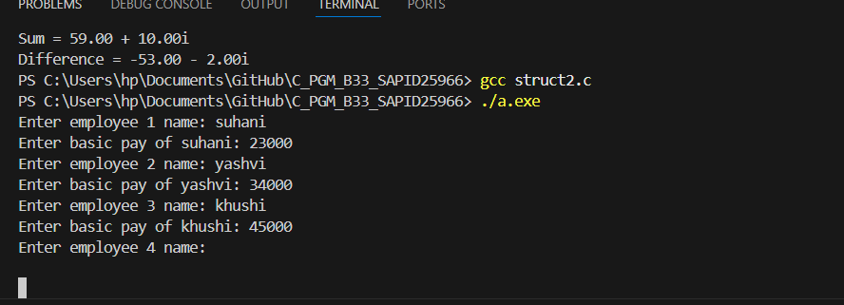
- Create a Book structure containing book_id, title, author name and price. Write a C program to pass a structure as a function argument and print the book details.
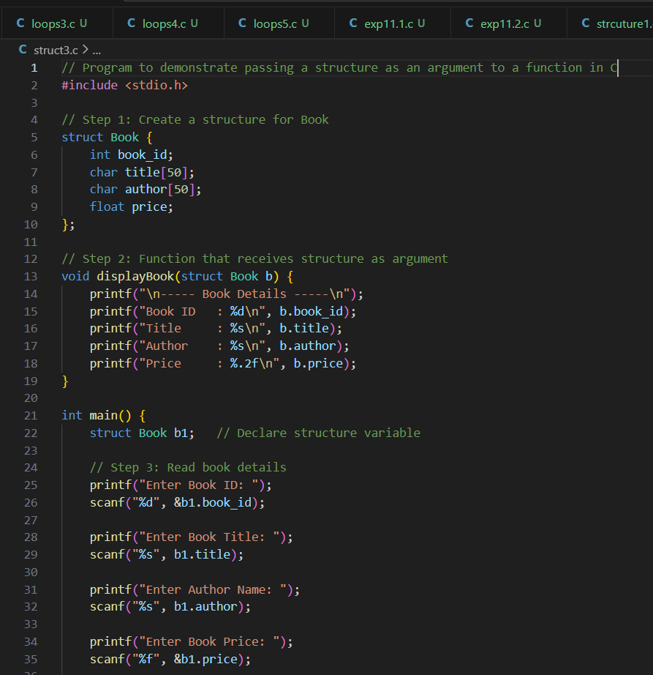
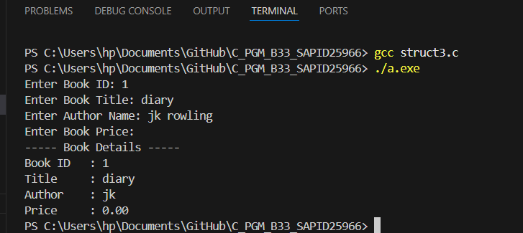

Experiment 8: Pointers
- Declare different types of pointers (int, float, char) and initialize them with the addresses of variables. Print the values of both the pointers and the variables they point to.
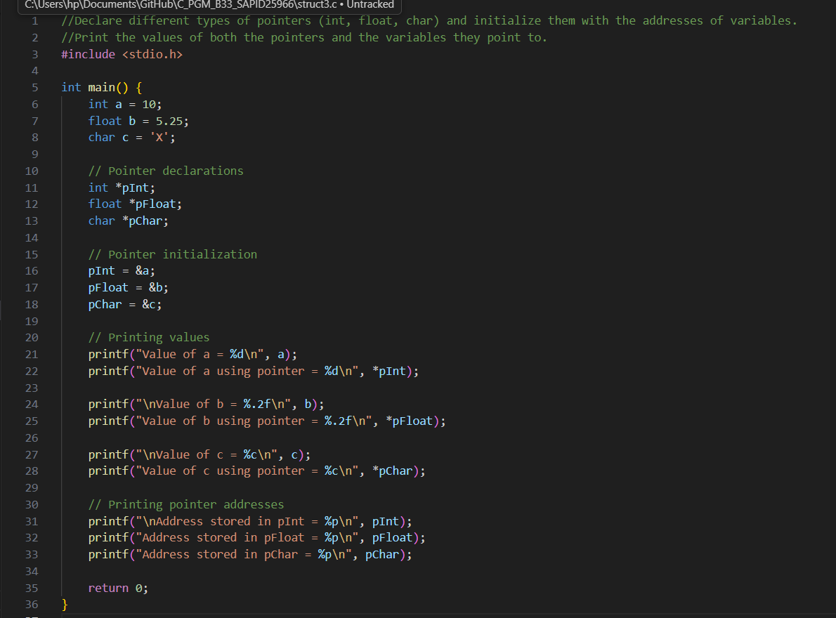
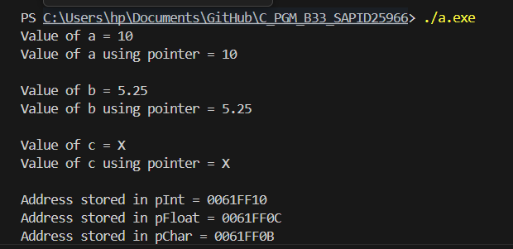
- Perform pointer arithmetic (increment and decrement) on pointers of different data types. Observe how the memory addresses change and the effects on data access.
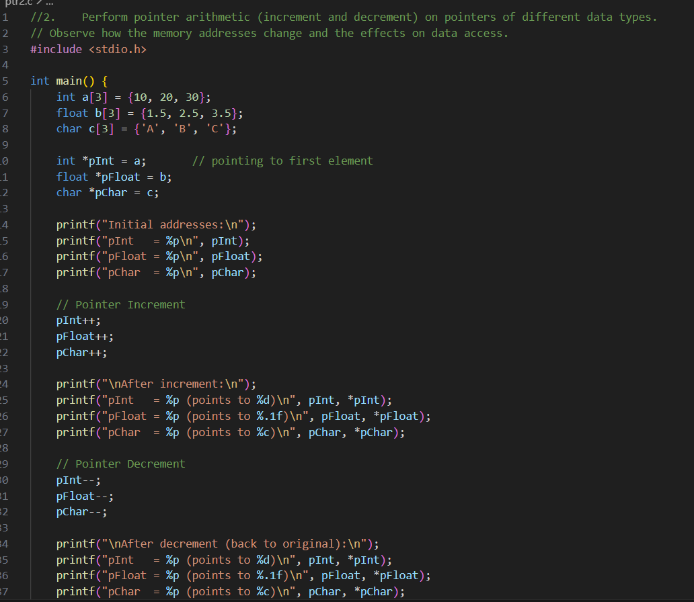
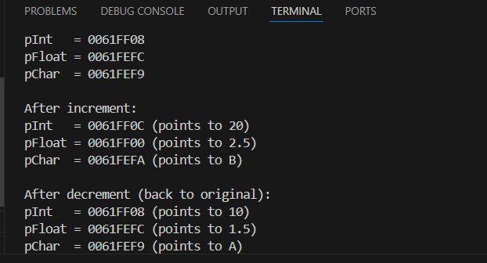

3. Write a function that accepts pointers as parameters. Pass variables by reference using pointers and modify their values within the function.

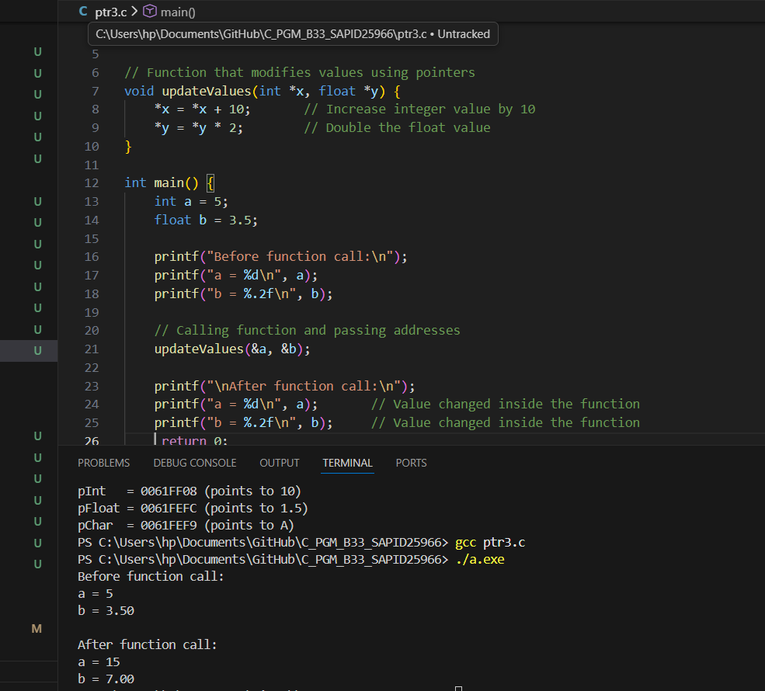
Experiment 11: Bitwise Operator
- Write a program to apply bitwise OR, AND and NOT operators on bit level.
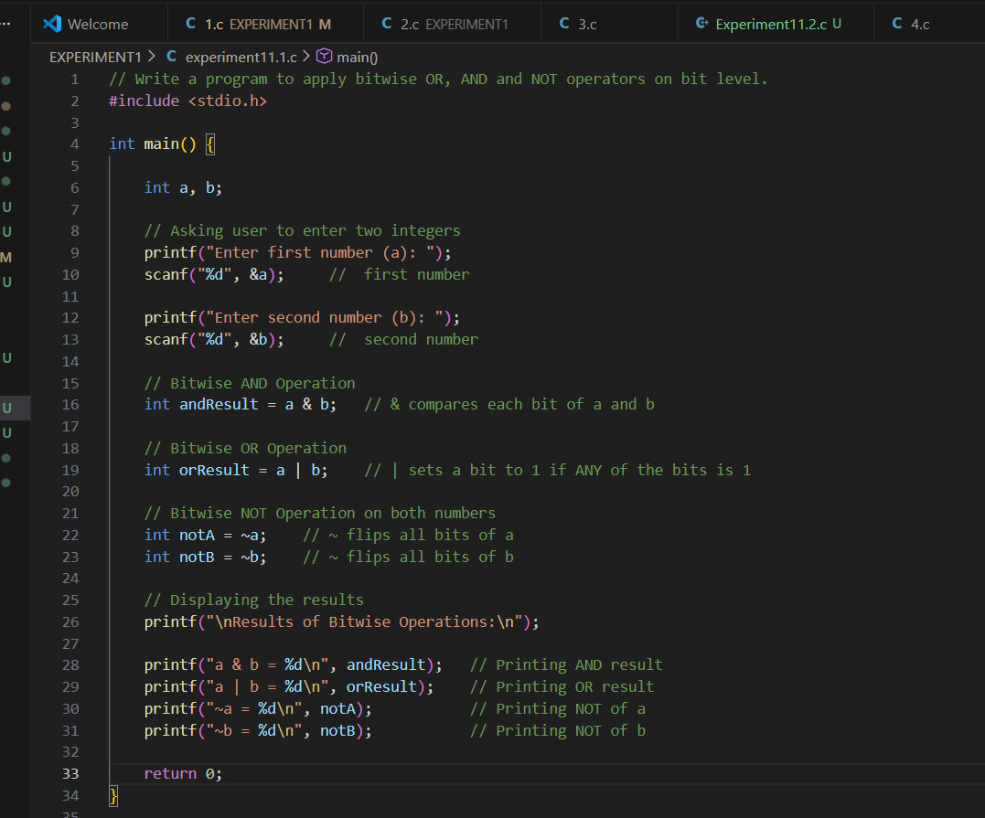
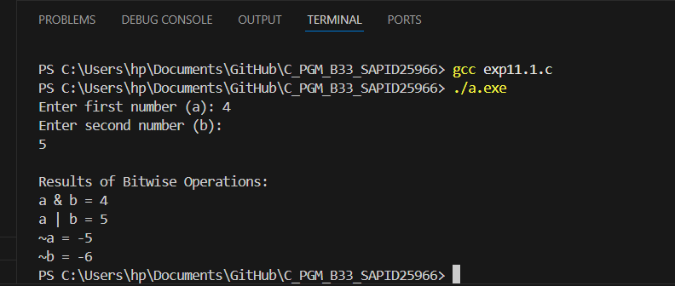

- Write a program to apply left shift and right shift operator.
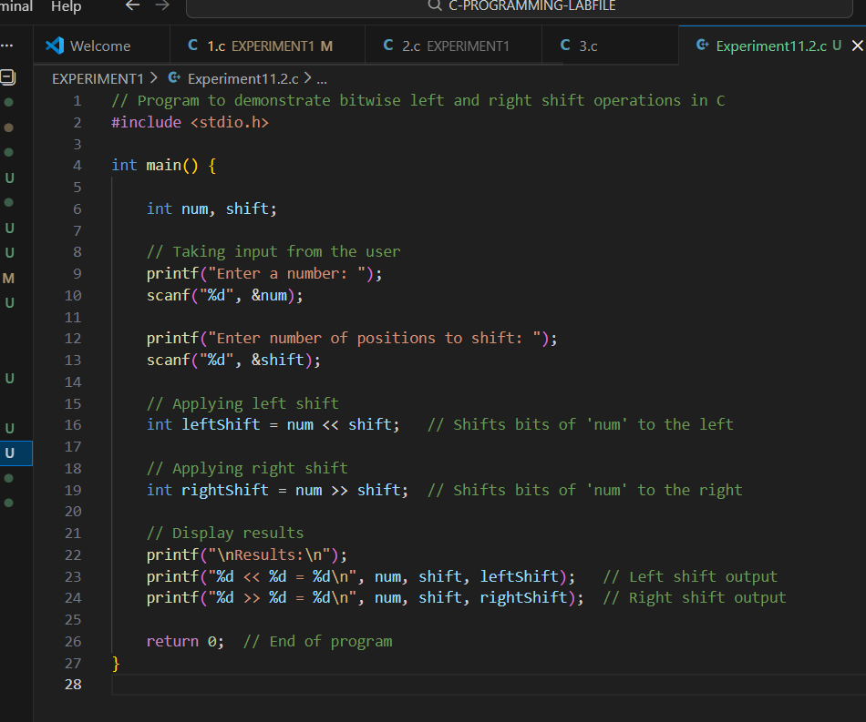
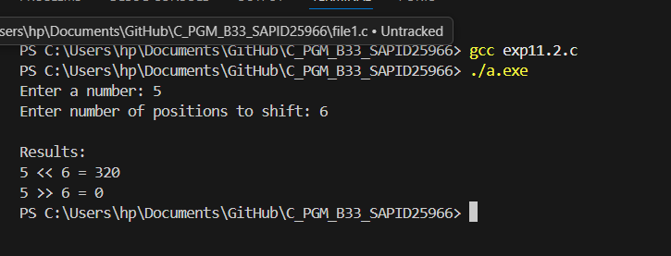

Experiment 10: Dynamic Memory Allocation
- Write a program to create a simple linked list in C using pointer and structure.
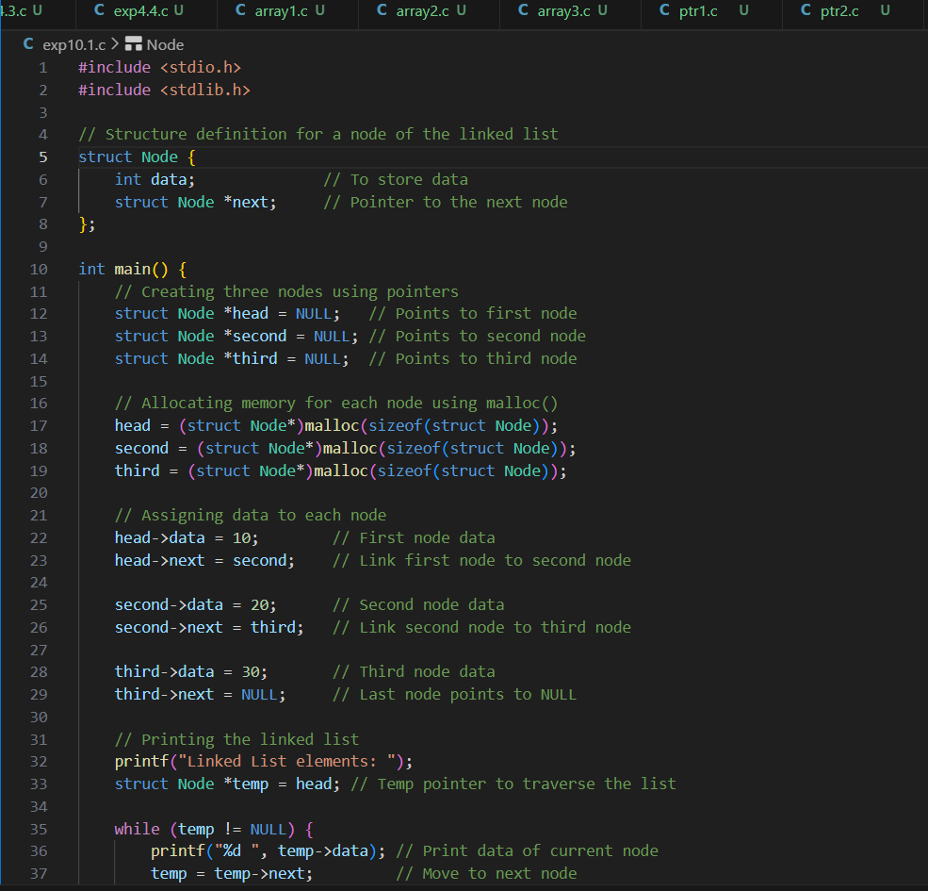
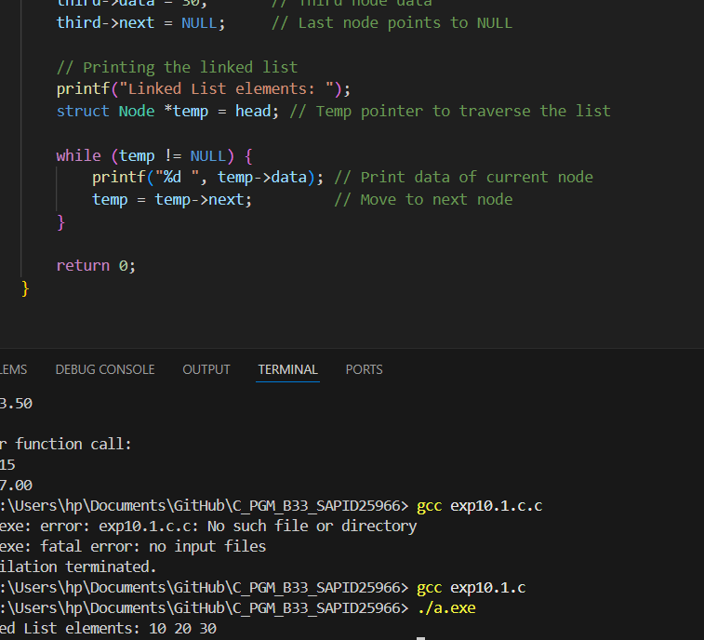
- Write a program to insert item in middle of the linked list.
Did not understand

